DEMOCRATIC REGIONS PARTY
REPORT ON WOMEN AND STATE COMMISSIONER IN LOCAL GOVERNMENTS
Updated on: 14/02/2018

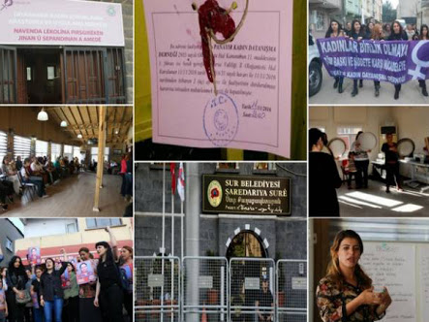

- INTRODUCTION:

After 40 years of war, in spite of the intense efforts by Kurdish popular leader Mr. Öcalan to achieve a lasting peace through democratic negotiation methods, AKP government declared war on 30 October 2014, with the scope of their plan called "forced collapse." Against this war, the local people went on to struggle to protect their existence. In this period, many cities and villages –including Şırnak, Cizre, Silopi, Sur, Nusaybin, Yüksekova and İdil– were destroyed by heavy artillery and an estimation of 2360 people, including 368 unarmed residents lost their lives. Over 400,000 people have been displaced during the process.
The insistence of the central state construct to implement war policies for a solution of the Kurdish issue has brought along a further systematic crisis. FETÖ structure, nurtured by the State against socialists and the Kurds for long decades, tried to benefit from this crisis, and a coup mechanism was put into action on July 15th. Within the scope of this mechanism of coup d’état, State of Emergency (OHAL) has been declared on July 19, democratic norms were suspended, the parliament became dysfunctional as the country was to be governed by Decrees with the Power of Law (KHK). The transformation of the system continued with a controversial referendum on April 16th.
When OHAL was declared shortly after the coup attempt on July 15th, the President was granted the right to issue Decrees with the Power of Law, to make legal amendments only with the approval of the Council of Ministers, without the need for any debate in the Parliament. Decree No. 674, dated August 15th, 2016, granted to Governors and District Governors the authority to appoint state commissioners to municipalities, to confiscate movable properties of the municipalities, and to terminate the employment of municipality workers. Based on this KHK, DBP municipalities have been seized, beginning as of September 11, 2016, and co-mayors have been arrested without clear grounds, disregarding basic principles of law.
Women are among the first communities who are most affected by OHAL and the anti-democratic practices it ensues. Women are faced with yet another discrimination policy on a daily basis in social, political, legal and economic spheres. Many achievements earned by women in both local and central administration are today at risk. We also witness that this political process usurps the rights of women including the right to life.
This report has been prepared with the aims to summarize the projects for women, carried out by our DBP municipalities until the appointment of the municipal administrations and to publicize the practices of the municipalities on women's work after their seizure by the central government trustees.

- WOMEN ORIENTED PROJECTS IN DBP MUNICIPALITIES BEFORE THE ASSIGNMENT OF STATE COMMISSIONERS
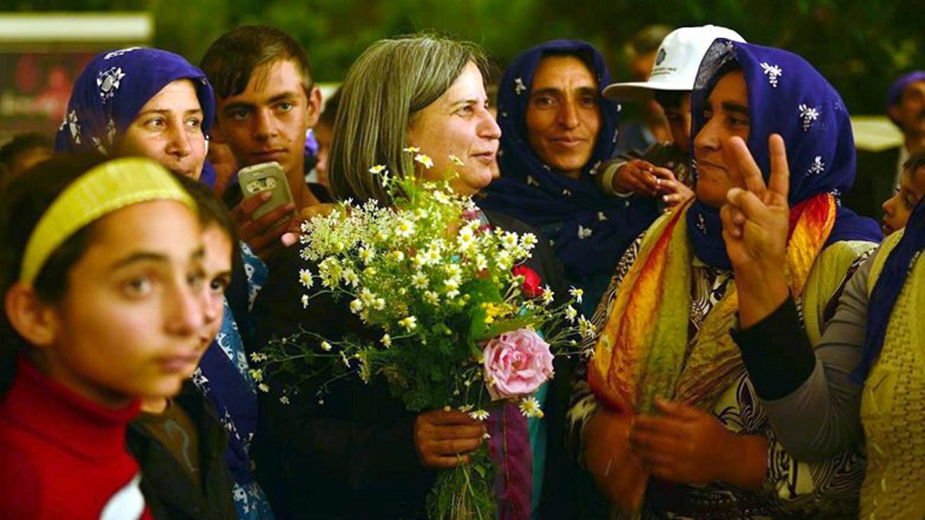

In 1999, in the elections we participated as HADEP, our experience with local administration has started with 3 women mayors, which became 9 in 2004 and 14 women mayors later in the elections in 2009. As of 2014, the experience of 15 years of local government brought with it a wealth of women's local government knowledge, strong in both quality and quantity.
-Increased awareness of gender equality in the region, women's freedom perspective, and the need for women to adopt a new model for stronger involvement in decision-making and implementation processes locally.
-With March 30, 2014 local elections, co-presidency system was implemented in which two co-chairs, 1 female and 1 male to be elected and equal representation to be implemented in all levels of local government. Thus, a great success has been achieved in the local elections through the co-chairmanship model in which the understanding of libertarian municipalism will pass through all stages of life, from city councils to neighborhood parliaments to the lives of radical and participatory democracies. First of all, 96 of the 102 municipalities were converted to a co-presidential system. 3 cities, 8 provinces and 85 districts started to implement the co-presidential system.
Graph 1: Woman mayors (◇ Total Number of Municipalities, □ Number of Woman Mayors)

With the Co-Presidency System, there has also been an increase in the number of women municipal council members. In the 2014 local elections, the number of women municipal council members in DBP increased from 190 to 363.

Graph 2: Women municipal council members (Number of Woman City Councilors)
After the 2014 local elections, "municipal women's councils" were elected and elected to effectively involve women in decision-making processes in the municipal councils, and "women's councils" and "women's councils" were chosen to carry out practical work of the council from within the council. Women and men equality commissions consisting of women and men elected and "women's groups" where women's electors came together and evaluated the agenda before the council works.

DBP municipalities, having gained considerable experience in women's policies, established "women's policies departments" and "women's policies directorates". Women's policies department offices in Van, Diyarbakir and Mardin Metropolitan Municipalities and directorates in provincial and some district municipalities were established and the departments have come to a new stage in women's work by establishing "units for strengthening the women's economy", "developing women's education" and "combating violence".

Within the scope of the combating violence, Women's Shelter Houses were opened in Diyarbakır Metropolitan City, Van Metropolitan City, Bağlar Municipality and Akdeniz Municipality, "First Step Station" and "Violence Hotline" were established in Diyarbakır Metropolitan City. Women's Centers were opened in our 43 municipalities. Some of the works conducted by our Women's Policies Directorates and Women's Centers can be listed as follows;
- In our women's centers, courses were opened according to the demands of the women living in the neighborhoods, including but not limited to carpeting, sewing, child education, handicrafts, hairdressing, computer, entrepreneurship, driving, accounting, musical instruments, chess, and creative drama.
- Thousands of women have been reached in hundreds of neighborhoods and women's centers through educational works on issues such as gender, women's health, breast cancer, uterine cancer, hygiene, birth control methods, reproductive rights, menopause, and forced marriage at early ages.
- Within the scope of the development of the women's economy, production workshops were established and soap, clothes, bags, wallets, belts, jewelry, shawls were produced; onion plant, green plant, tomato paste, pomegranate sour, molasses, jam production. Also, women's ovens and home-cooked dinners were opened. Women's appraisal centers and women's neighborhood markets have also created opportunities for women to produce pajamas.
- The daily lives of women are facilitated by opening laundry, carpet washing areas, kindergartens, meat houses in the direction of the neighborhood. Basketball, volleyball, swimming courses, women's sports complexes were opened and sports facilities for women were created.
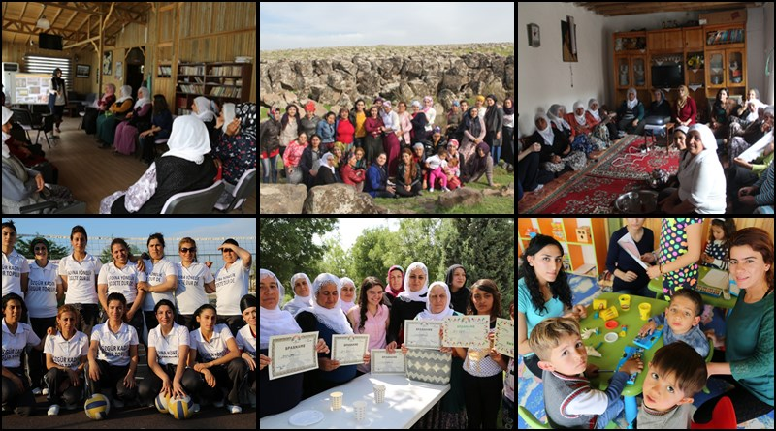 Photos from DBP Municipalities’’ Women’s Projects / Çınar Municipality Jînwar Women’s Center
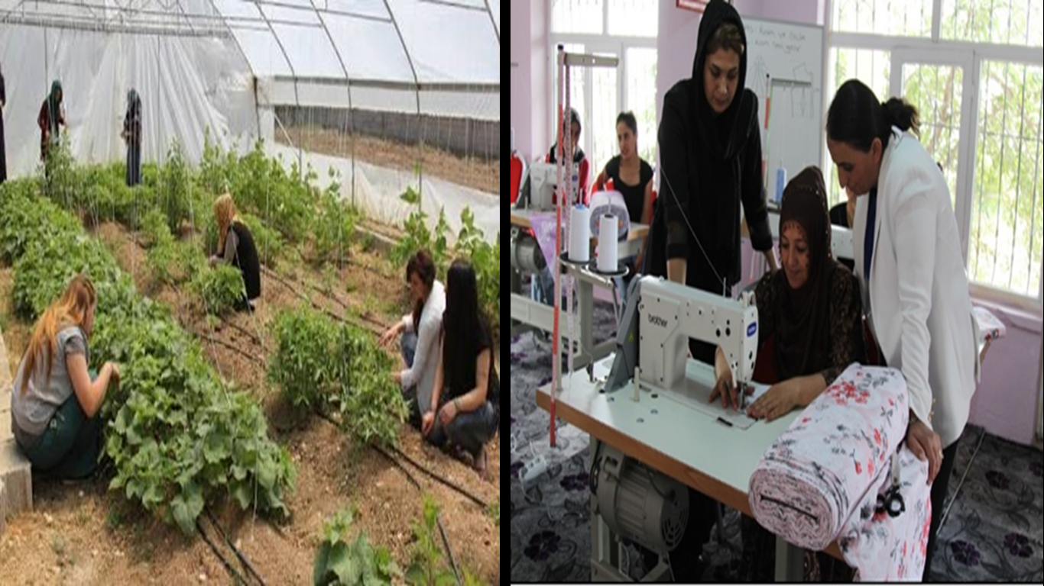
Photo: Women’s economy projects in Van Gürpınar Municipality
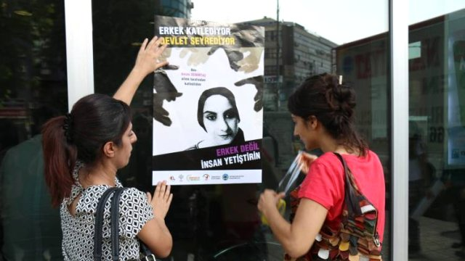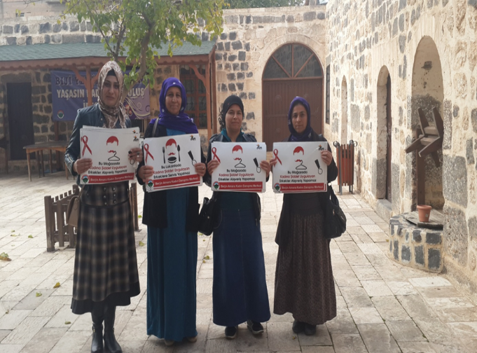
Photo: Projects for awareness against violence by Women’s Centers in Batman and Viranşehir Municipalities

- PRESENT SITUATION WITH STATE COMMISSIONERS AND WOMEN’S PROJECTS:
Before appointing State Commissioners as a means of usurping our municipalities, AKP government first terrorized our municipal co-presidents through unlawful arrests. 45 female co-mayors have been arrested along with the appointment of State Comissioners. The number of women co-mayor still in prison is 24. The situation of our female co-presidents is indicated in the following table:
Table: The total number of women co-mayors in prison is 24, and 8 of them are sentenced.
 | Co-mayor | City/Province | Date of Arrest | Prison
1. | Dilek Hatipoğlu | Co-Mayor of Hakkari | 25.08.2015 | Ankara/Sincan Women’s Prison
2. | Diba Keskin | Co-Mayor of Erciş, Van | 15.10.2015 | Ankara /Sincan Women’s Prison
3. | Figen Yaşar | Co-Mayor of Bulanık, Muş | 23.04.2016 | Bayburt M-Type Prison
4. | Zeynep Sipçik | Co-Mayor of Dargeçit, Mardin | 31.03.2016 | Ankara/Sincan Women’s Prison
5. | Gültan Kışanak | Co-Mayor of Diyarbakır Metropolitan Municipality | 31.10.2016 | Kandıra F-Type Prison, Kocaeli
6. | Servin Karakoç | Co-Mayor of Ovakışla, Bitlis | 31.10.2016 | Ankara/Sincan Women’s Prison
7. | Sabite Ekinci | Co-Mayor of Varto, Muş | 10.11.2016 | Muş E-Type Prison
8. | Nurhayat Altun | Co-Mayor of Tunceli | 17.11.2016 | Kocaeli F-Type Prison No:1 Kocaeli
9. | Meymune Sönmez | Co-Mayor of Malazgirt, Muş | 28.11.2016 | Bitlis E-Type Prison
10. | Leyla Salman | Co-Mayor of Kızıltepe, Mardin | 02.12.2016 | Şakran Women’s Prison, İzmir
11. | Hilal Duman | Co-Mayor of Çukurca, Hakkari | 08.12.2016 | Van F-Type Prison
12. | Zeynep Han Bingöl | Co-Mayor of Karayazı, Erzurum | 09.12.2016 | Erzurum E-Type Prison
13. | Mukaddes Kubilay | Co-Mayor of Ağrı | 28.12.2016 | Ankara/Sincan Women’s Prison
14. | Sadiye Sür Baran | Co-Mayor of Kulp, Diyarbakır | 06.01.2017 | Şanlıurfa T-Type Prison
15. | Sara Kaya | Co-Mayor of Nusaybin, Mardin | 26.01.2017 | Van E-Type Prison
16. | Delal Tekdemir | Co-Mayor of Doğubeyazıt, Ağrı | 05.02.2017 | Van E-Type Prison
17. | Evin Keve | Co-Mayor of Çatak, Van | 16.02.2017 | Ankara/Sincan Women’s Prison
18. | Belkıza Beştaş Epözdemir | Co-Mayor of Siirt | 09.05.2017 | Siirt E-Type Prison
19. | Rezan Zuğurli | Co-Mayor of Lice, Diyarbakır | 17.08.2017 | Van T-Type Prison
20. | Sevinç Bozan | Co-Mayor of Artuklu, Mardin | 28.09.2017 | Mardin E-Type Prison
21. | Zülfiye Kişmir | Co-Mayor of Dicle, Diyarbakır | 12.09.2017 | Diyarbakır E-Type Closed Prison
22. | İpek Güneş | Co-Mayor of Ömerli, Mardin | 06.01.2018 | Mardin E- Type Prison
23. | Gurbet Tekin | Co-Mayor of Savur, Mardin | 12.08.2017 | Bayburt Women’s Prison
24. | Hazal Aras | Co- Mayor of Diyadin , Ağrı | 09.02.2018 | Patnos Prison, Ağrı

Table: Female Co-Mayors in the Kurdish Region Sentenced by the Turkish Courts (14-02-2018)
 | Co-Mayor | Title | Province | Detention | Sentence | Date of Verdict
1 | Ms. Diba Keskin | Co-Mayor of Ercis | Van | 15/10/2015 | 13 years 9 month imprisonment | 13/03/2017
2 | Ms. Fatma Şık Barut | Co-Mayor of Sur | Diyarbakır | 23/08/2015-  09/03/2016 | 11 years 3 month imprisonment | 04/05/2017
3 | Ms. Dilek Hatipoğlu | Co-Mayor of Hakkari | Hakkari | 08/25/2015 | 15 years imprisonment | 25/03/2016
4 | Ms. Zuhal Tekiner | Co-Mayor of Silvan | Hakkari | Not detained | 1 year 3 months imprisonment (The sentence reversed by the  regional court, the trial will be  repeated) | 12/07/2017
5 | Ms. Rezan Zuğurli | Co-Mayor of Lice | Diyarbakır | 17/08/2017 | 4 years (1 year 2 months already gone)
6 | Ms. Petek Çapanoğlu* | Co- Mayor of Eğil | Diyarbakır | Not detained | 7 years 6 months | 02/11/2017
7 | Ms. Zeynep Han Bingöl | Co-Mayor of Karayazı | Erzurum | 09/12/2016 | 7 years 6 months imprisonment | 07/11/2017
8 | Ms. Gurbet Tekin | Co-Mayor of Savur | Mardin | 12/08/2017 | 3 years 45 days imprisonment

With the appointment of state commissioners, attempts have been made to eliminate women's studies which were institutionalized by DBP municipalities. The decision to close women's centers and shelters, the removal of employees from the Women's Policies Directorate or the change of places of duty, is intended to be a direct end to the struggle of women's struggles and their achievements in relation to local governments. In this context, the works in the provinces and districts on combatting violence against women, the awareness and services developed on the axis of women's struggle have become the first targets of the trustees, and they have been terrorized and stopped.
- The decisions that the state commissioners have taken against women in municipalities and the similarities between the policies of the AKP government and the policies implemented by the mind of the AKP government are a common treaty of misogynist policies in the loyalty of the state commissioners to the AKP government. It is possible to list the misogynist and sexist policies of the state commissioners by their activities:

- Dismissal of women employees,
- Locking down women’s institutions,
- Dislocation of women employees,
- Appointments of male officers for the administration of women’s departments
- By abolishing the Women's Centers and the Women's Political Directorates and linking them to the Social Affairs Directorate, ensuring that the Women's Center staff is limited only to projects of social aid,
- By not leaving women employees in municipalities, obstructing women's employment and developing a sexist approach in distribution of duties,
- Changing the names of Women’s Parks,
- Confiscation the files of women applying to Women’s Centers, therefore violating the right to privacy, and thus putting the life of women at risk,
- Closure of kindergartens or the preventing services in the mother tongue, restricting the services with the Turkish language only, and assigning the kindergartens to provincial and district muftis, using kindergartens for Quran courses.
- Deleting retrospective service archive of web sites of municipalities, removing photographs and services of co-mayors, as well as eliminating institutionalization of women, culture and multilingualism in web sites and offering only religion, environment and sanitary services,
- Unfair use of women’s center buildings by AKP Women and Youth branches,
- Transformation of Women’s Centers into marriage offices or Quran courses,
- By submitting the units, headquarters, departments and shelters to provincial directorates affiliated to the Ministry of Family and Social Policies and delivering them to ŞÖNİM (Violence Prevention and Monitoring Center) or allocating them to KADEM,
- Conversion of dormitories for university students into hospitals and guesthouses for law enforcement officers by the Trustees,
- Decisions such as expelling women from Women’s Local Markets, and other economic projects
These are common decisions, generally applied by Trustees in 94 DBP municipalities to which they were appointed.
The Women's Centers that have been shut down, halted, or modified in content are listed in the following table:
PROVINCE | WOMEN’S CENTRES HALTED BY STATE COMMISSIONERS
DİYARBAKIR | -Diyarbakır Metropolitan Municipality- DİKASUM  -Kayapınar Municipality Ekin Ceren Women's Center  -Sur Municipality Amida Women's Center  -Yenişehir Municipality Roza Women's Center  -Çınar Municipality Jînwar Women's Center  -Silvan Municipality Meya Women's Center  -Lice Municipality Nujian Women's Center  -Kulp Municipality Zozan Eren Women's Center  -Hani Municipality Women's Center  -Bismil Municipality Nujin Women's Center
BATMAN | -Batman Selis Women's Center  -Hevi Women’s Workshops
BİTLİS | -Bitlis Municipality Dilan Women's Center
MARDİN | -Mardin Metropolitan Municipality Arin Women's Center  -Kızıltepe Municipality Nuda Women's Center  -Nusaybin Municipality Gûlşilav Women's Center  -Mazıdağ Municipality Rewşen Women's Center  -Dargeçit Municipality Çiçek Women's Center  -Derik Municipality Peljîn Women's Center
ŞIRNAK | -Şırnak Municipality Zahide Women's Center  -Cizre Municipality SitiyaZin Women's Center  -Silopi Municipality Viyan Women's Center
URFA | -Viranşehir Municipality BerjinAmara Women's Center  -Halfeti Municipality Sara Women's Center
VAN | -Van Metropolitan Municipality Rojin Women's Life Center  -İpekyolu Municipality Maya Women's Life Center  -Erçiş Municipality Kadın Support Home  -Bahçesaray Municipality Women's Life Center
HAKKÂRİ | -Hakkâri Municipality Binevş Women's Center  -Çukurca Municipality Bervar Women's Center  -Şemdinli Municipality Nujîn Women's Center
AĞRI | -Doğubeyazıt Municipality Sema Yüce Women's Center
SİİRT | -Siirt Municipality Berfin Women's Center  - Baykan Municipality Arîn Women’s Counselling Center
MUŞ | -Varto Municipality Savuşka Women’s Center
DERSİM | -Dersim Municipality Life and Women’s Center
MERSİN | -Akdeniz Municipality İştar Women’s Center

- EXAMPLES OF POLICIES BY STATE COMMISSIONERS ON WOMEN’S PROJECTS
PROVINCE | ATTACKS BY STATE COMMISSIONERS ON WOMEN’S PROJECTS
DİYARBAKIR | - The Chair of Department of Women Policies, affiliated to Diyarbakır Metropolitan Municipality, was taken from her position and all projects were suspended. All women's projects were attached to the Department of Family and Social Affairs, by appointing a male assistant instead of the Vice-chair of the Women's Department. Violence Hotline and First Step Station services were discontinued and DİKASUM, our first women's center in local administrations, and the employees affiliated with Women's Department were dismissed from the positions.  - The 227-bed all-female student dormitory, built by the Metropolitan Municipality for female students, was evacuated by the state commissioner and the dormitory building is allocated as a guesthouse to the relatives of patients.  - State Commissioner of Diyarbakir Bismil Municipality converted Nujin Women's Center to a Marriage office.  - 10 women’s centers active in Diyarbakır have been halted.
BATMAN | - By linking the Directorate of Women Policies to the Social Affairs Directorate, the trustee of Batman Municipality closed down the Hevi Women's Workshop and Selis Women's Center and their employees were dismissed.  - The women's sports complex, opened by Batman municipality exclusively for women, was taken away from the women, by a transformation into a mixed-gender sports center by the trustee.
MARDİN | - A male officer has been appointed as chairman to the Women's Department of Mardin Metropolitan Municipality.  - Mardin Nusaybin Municipality Gulşilav Women's Center has been closed down by the state commissioner. The women’s labor project "Jiyana Be Sinor", to employ 70 women, was halted by the trustee.  - Local Governor Ahmet Odabaşı, who was appointed to Kızıltepe Municipality as a state commissioner, decided to convert the Ubeydullah Eren Healthy Life Area, opened in 2015 for giving sports and fitness training to women, into a Quran school. The state commissioner had also transformed the Nuda Women’s Institution founded by the achievements of women, into “Lady Bugs”. The state commissioner also distributes religious books and propaganda material on July 15th to minor children.
ŞIRNAK | - State commissioner of Şırnak Cizre Municipality, abolished the Women’s Policy Directorate, dismissing all employees. Also, Sitiya Zin Women’s Center was locked down, confiscating confidential information and files of the women who had applied for counselling. Now the center is being used exclusively by AKP Women’s branch as a cultural center.  - State commissioner of Şırnak Municipality locked down Zahide Women’s Center and Cudi Cultural Center.
VAN | - State commissioner of Van Metropolitan municipality has abolished the Directorate of Women’s Policies and has also closed the Women's Shelter, which provides support and services for women who are victimized by violence. Dozens of women whose lives were in danger stayed in the shelter. Also, women who were employed as public bus drivers as a part of the project named "Violet Cranes", have been dismissed by the sexist discourse and practices by the state commissioner. The State Commissioner outspokenly said that women “are not capable of” being drivers.  - The name of the Rojin Women's Life Center was changed as "Women's Life Center", and the center has been turned into a Quran school for minors. The Rojin Women's Life Center, opened by the DBP municipality as a space exclusively for women, has been altered to include men. The state commissioner brought in an original idea and started using the women’s center for Ottoman military band training. In addition, the interior walls of the Rojin Women's Life Center, previously colored with pictures of women, have been redesigned with pictures of July 15th although it is still a "Women's Life Center"  - State commissioner of Van Edremit municipality has brought down the nameplate of Women’s Policies Directorate, transformed the building into a service unit and appointed a male director. Words such as “women” or “peace” were erased from the park names by the State Commissionerof Edremit.  - State Commissioner of Van Erciş Municipality has closed down a major women’s project, “Buke Barane Workshops”. 60 women suffered when the women’s economy and employment project was halted. Helin Şen Kindergarten, attached to the municipality, was also closed down by the State Commissioner.  - State commissioner of Van Gürpınar Municipality transferred the women’s life center to KADEM. The state commissioner also appointed his wife as the director of a kindergarten.  - In Van İpekyolu municipality, the telephone belonging to the anti-violence unit was confiscated by the State Commissioner, preventing any anti-violence services.  - A 202-bed Higher Education Female Students’ Dorm project, which was prepared in order to solve the problem of housing for female university students in Van, was stopped by the State Commissioner.
AĞRI | - Sema Yüce Women's Center, Ayşenur Zarokolu Medical Center, Kindergarten and Laundry attached to Ağrı Doğubeyazıt Municipality were closed by the State Commissioner.
MERSİN | - State Commissioner of Mersin Akdeniz Municipality has closed down İştar Women’s Center and transferred the Women’s Center to the Family and Social Policies Directorate without any council decision.  - Also, the Women’s Shelter of the municipality has been transformed into a picnic area.

- CONCLUSION:
The appointment of state commissioners is the usurpation of local democracy and the people’s will. In DBP municipalities confiscated through trustees, the first targets were women's projects. Many achievements of the women's movements in Turkey, especially Kurdish women's movement, have been disabled by state commissioners. DBP municipalities, one of the most important mechanisms for promoting women's socialization in politics and social life, have been transformed into areas of practice for sexist and nationalist policies. In this respect, the closure of institutions such as women's shelters and counseling centers have led to the desolation of women against violence. The immediate abandonment by the Government of Turkey of this OHAL-KHK process and State Commissioner policies is an urgent requirement for everyone, but especially for women. Implementation of basic principles of democracy and the European Charter for Local Equality in Local Life, the European Local Authorities Convention, CEDAW, the Istanbul Convention is a requirement, as Turkey needs to fulfill its democratic responsibilities.

Starting from the 1990s, many parties such from the same political tradition have been established such as HEP, DEP, OZDEP, HADEP, DEHAP, DTP and BDP but these parties have either been closed for some reason or have to be terminated. While participating in the 2014 local elections as a BDP, the following works were conducted under the name DBP.
KADEM (Association of Women and Democracy) is an association that is known to be close to AKP, and is founded by President Erdoğan's daughter, Sümeyye Erdoğan, trying to build a submissive model for women for AKP.
http://www.tigrishaber.com/kayyum-46-kadinin-isine-son-verdi-41791h.htm
http://gazetekarinca.com/2017/07/bir-kayyum-icraati-kadin-yasam-merkezi-kuran-kursuna-donusturuluyor/
https://www.artigercek.com/kayyum-kadin-merkezinden-rojin-adini-kaldirdi

